Code Assignment
See Video - here
HTML/CSS
Please implements the following design using HTML/CSS. Use your desire CSS library if you wish. Use the resources in this repository – here
Copy text from this original site – source
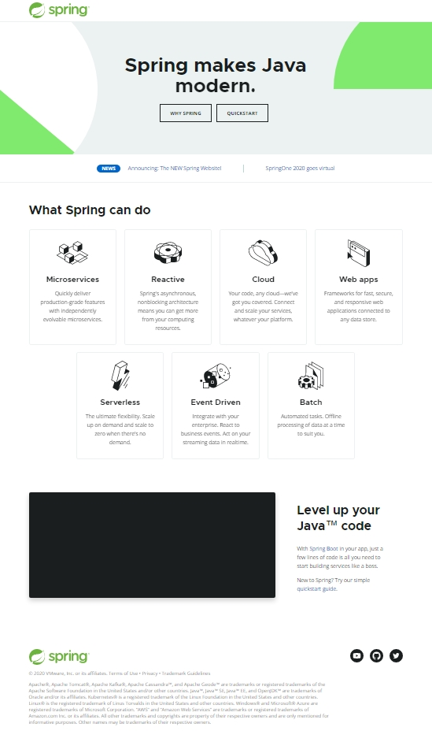

JavaScript
This assignment is to review your JavaScript knowledge and practice code reading skills. Source – here
(1) Run the program and try to understand the program flow.
(2) Read the codes.
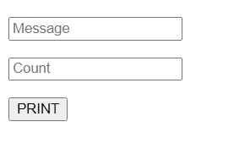
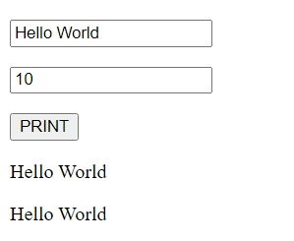

Try out
(3) create a new button “Clear” and add the “click” event and perform clear the child elements of "context" element.
(4) create two new input “Text Color” and “Background Color” and get value from therm in “PRINT” button “click” event and apply output text style. Ref
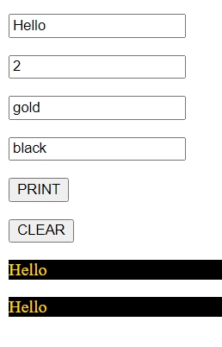

Logical Thinking
Write a program for the following problem to solve. You can use your preferred programming language. The program can be in the CLI(Command Line Interface) version or GUI(Graphic User Interface) version.

Story
Let emergence that you're a shopping lover and always eyes keeping for discounts. The problem is that every time you have to calculate yourself how much money you can save over the particular discount item. Every case you know the sale price and discount amount or percentage. The formula for the discount price calculation can reference here.

Specification
(1) The program should accept the sale price and discount price (or) percentage.
(2) The program should output the price you have to pay after the discount.
(3) The program should also output the amount you saved on the discount.

